1.create a database called music?

Use music

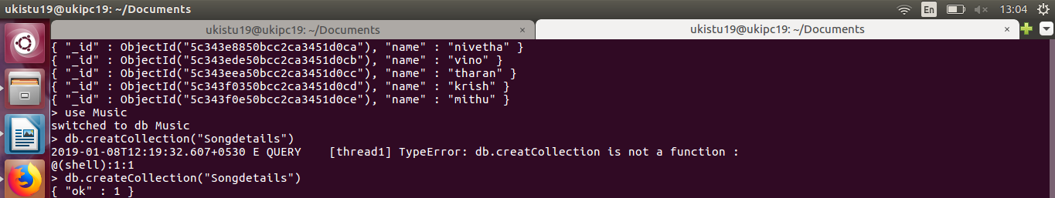

2.create a collection called song Details?

db. create Collection("Song Details")

3.create the 5 songs document?
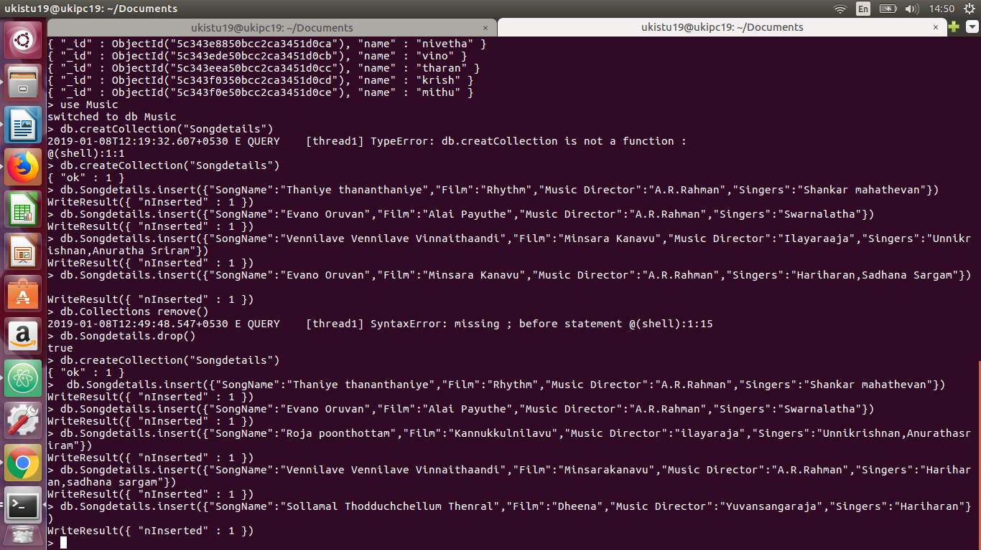
db. Songdetails.insert({"Song Name":"Thaniye thananthaniye","Film":"Rhythm","Music Director":"A.R.Rahman","Singers":"Shankar”

4.list all document created?

db.Songdetails.find()
db.Songdetails.find().pretty()

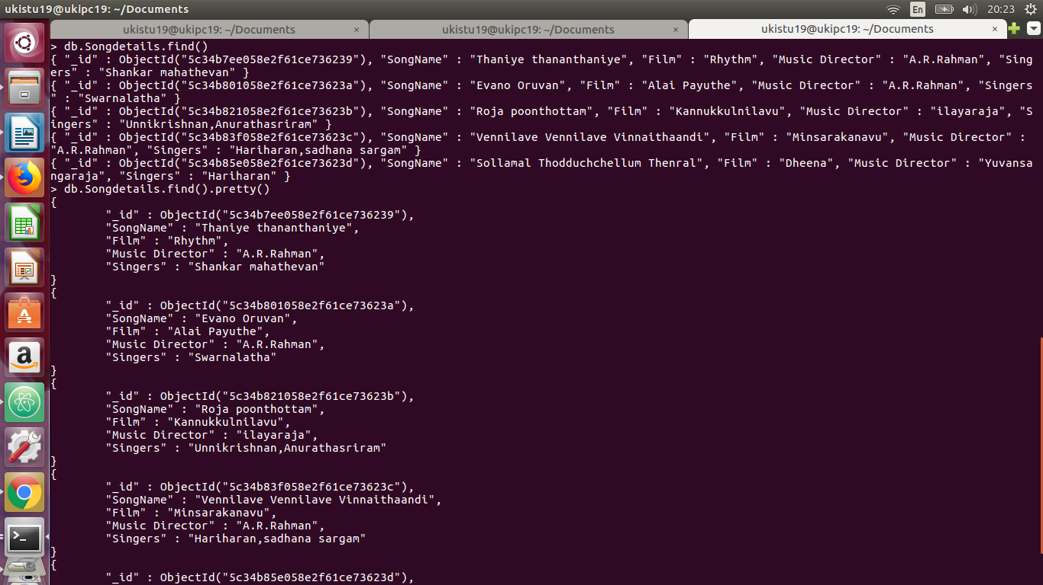

5) List A.R.Rahman’s songs.

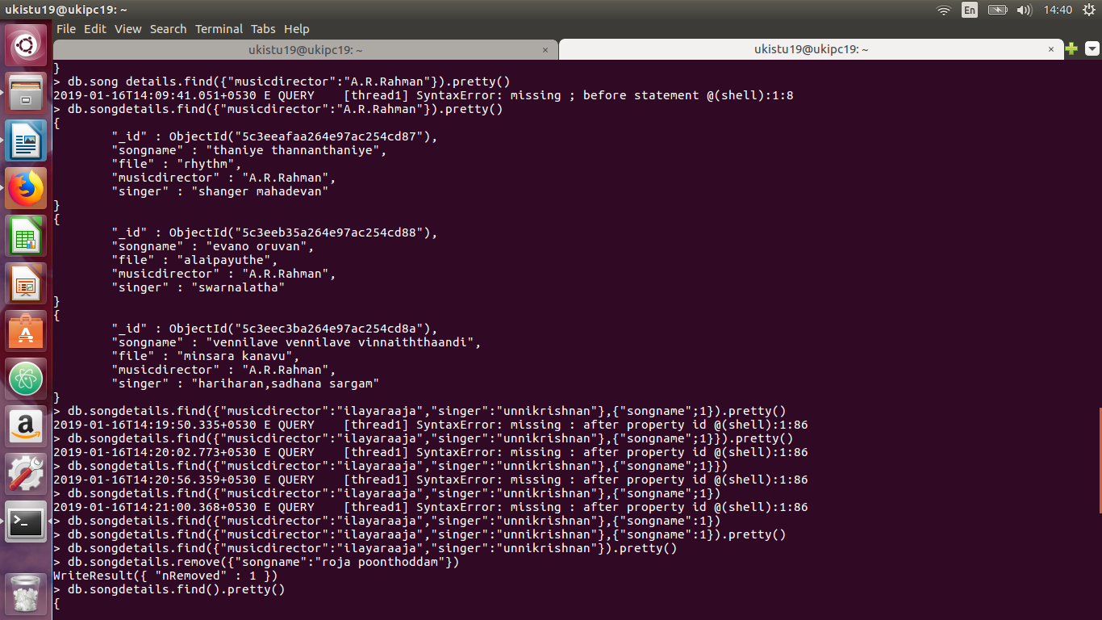

6) List ilayaraja’s songs sung by Unnikrishnan.

7) Delete the song which you don’t like.

8) Add new song which is your favourite.
9) List Songs sung by Hariharan from Minsara kanavu film.
10)List out the singers’ names in your document.

